

MAQUETACIÓN

PORTADA PERIÓDICO

ONLINE

**MARIO JIMÉNEZ MARSET**

**ÍNDICE**

1. ENUNCIADO - OBJETIVOS 3

2. DESARROLLO - CÓDIGO 3

# ENUNCIADO - OBJETIVOS

En esta práctica de lenguaje de marcas, se pedía crear una página html igual que la dada en el enunciado. Esta debía hacerse a partir de un fichero css externo.

La clave de este ejercicio era utilizar las “Técnicas de Posicionamiento”.

# DESARROLLO - CÓDIGO

En primer lugar, se ha creado un fichero css externo, cuyas características se aplican en el html posterior.

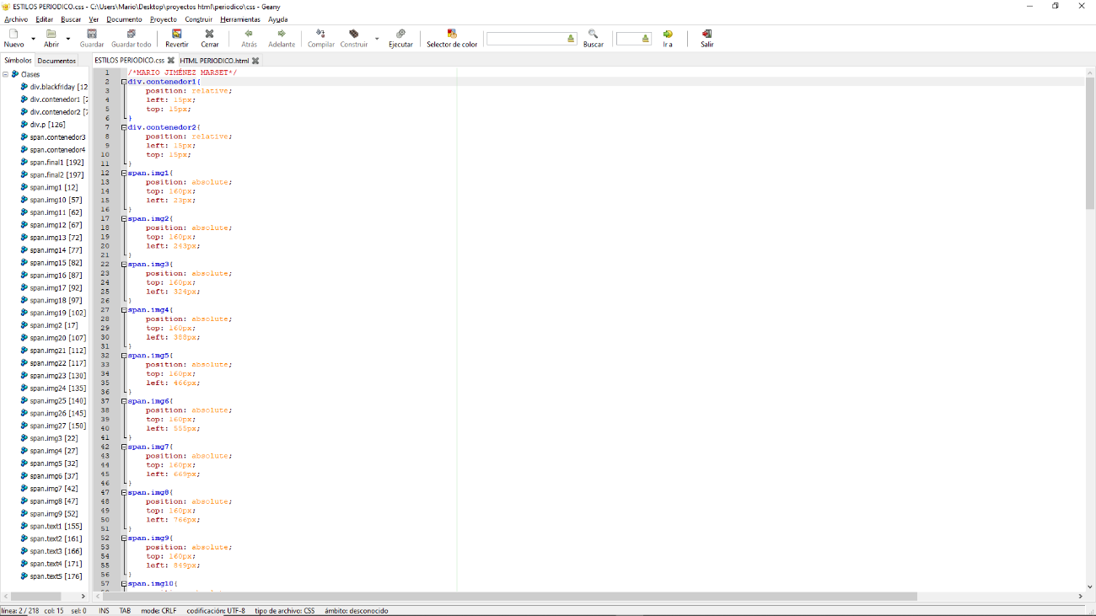

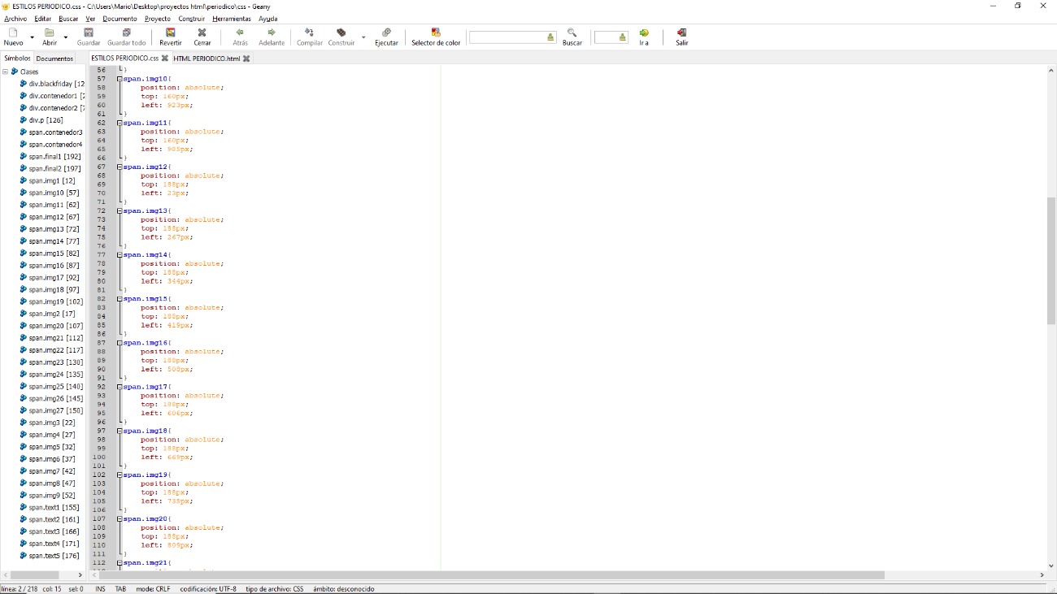

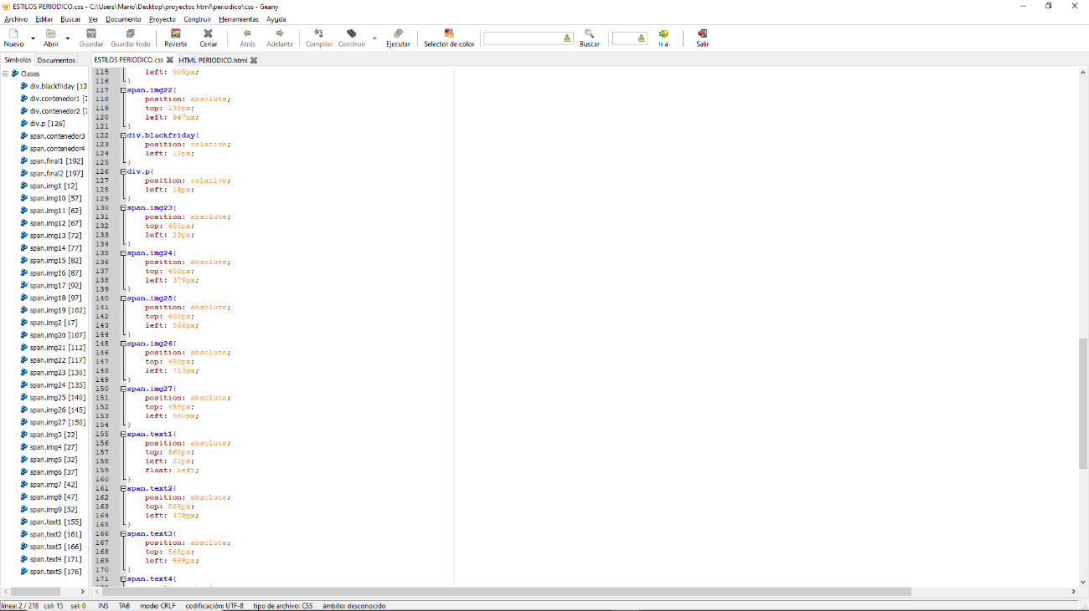

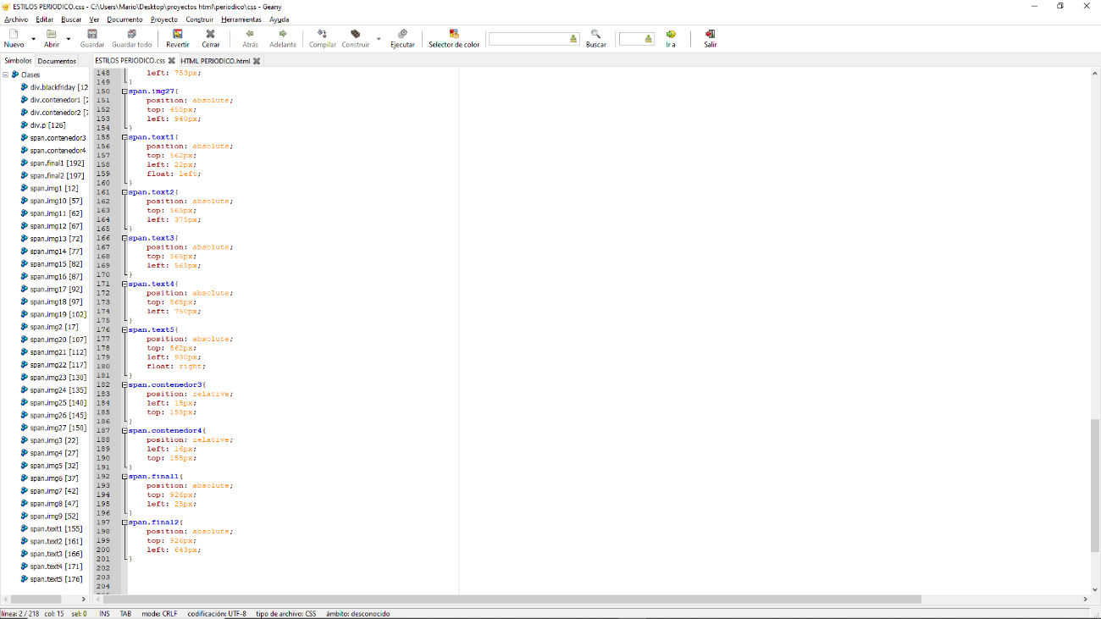

Código del CSS (utilizando técnicas de posicionamiento relative y absolute)

/*MARIO JIMÉNEZ MARSET*/

div.contenedor1{

position: relative;

left: 15px;

top: 15px;

}

div.contenedor2{

position: relative;

left: 15px;

top: 15px;

}

span.img1{

position: absolute;

top: 160px;

left: 23px;

}

span.img2{

position: absolute;

top: 160px;

left: 243px;

}

span.img3{

position: absolute;

top: 160px;

left: 324px;

}

span.img4{

position: absolute;

top: 160px;

left: 388px;

}

span.img5{

position: absolute;

top: 160px;

left: 466px;

}

span.img6{

position: absolute;

top: 160px;

left: 555px;

}

span.img7{

position: absolute;

top: 160px;

left: 669px;

}

span.img8{

position: absolute;

top: 160px;

left: 766px;

}

span.img9{

position: absolute;

top: 160px;

left: 849px;

}

span.img10{

position: absolute;

top: 160px;

left: 923px;

}

span.img11{

position: absolute;

top: 160px;

left: 985px;

}

span.img12{

position: absolute;

top: 188px;

left: 23px;

}

span.img13{

position: absolute;

top: 188px;

left: 267px;

}

span.img14{

position: absolute;

top: 188px;

left: 344px;

}

span.img15{

position: absolute;

top: 188px;

left: 419px;

}

span.img16{

position: absolute;

top: 188px;

left: 508px;

}

span.img17{

position: absolute;

top: 188px;

left: 606px;

}

span.img18{

position: absolute;

top: 188px;

left: 669px;

}

span.img19{

position: absolute;

top: 188px;

left: 735px;

}

span.img20{

position: absolute;

top: 188px;

left: 809px;

}

span.img21{

position: absolute;

top: 188px;

left: 909px;

}

span.img22{

position: absolute;

top: 188px;

left: 947px;

}

div.blackfriday{

position: relative;

left: 15px;

}

div.p{

position: relative;

left: 15px;

}

span.img23{

position: absolute;

top: 458px;

left: 23px;

}

span.img24{

position: absolute;

top: 458px;

left: 379px;

}

span.img25{

position: absolute;

top: 458px;

left: 566px;

}

span.img26{

position: absolute;

top: 458px;

left: 753px;

}

span.img27{

position: absolute;

top: 458px;

left: 940px;

}

span.text1{

position: absolute;

top: 562px;

left: 22px;

float: left;

}

span.text2{

position: absolute;

top: 565px;

left: 375px;

}

span.text3{

position: absolute;

top: 565px;

left: 565px;

}

span.text4{

position: absolute;

top: 565px;

left: 750px;

}

span.text5{

position: absolute;

top: 562px;

left: 930px;

float: right;

}

span.contenedor3{

position: relative;

left: 15px;

top: 155px;

}

span.contenedor4{

position: relative;

left: 16px;

top: 155px;

}

span.final1{

position: absolute;

top: 926px;

left: 25px;

}

span.final2{

position: absolute;

top: 926px;

left: 643px;

}

Con esto realizado, se procede a hacer el código html, el cuál mostrará la portada del enunciado.

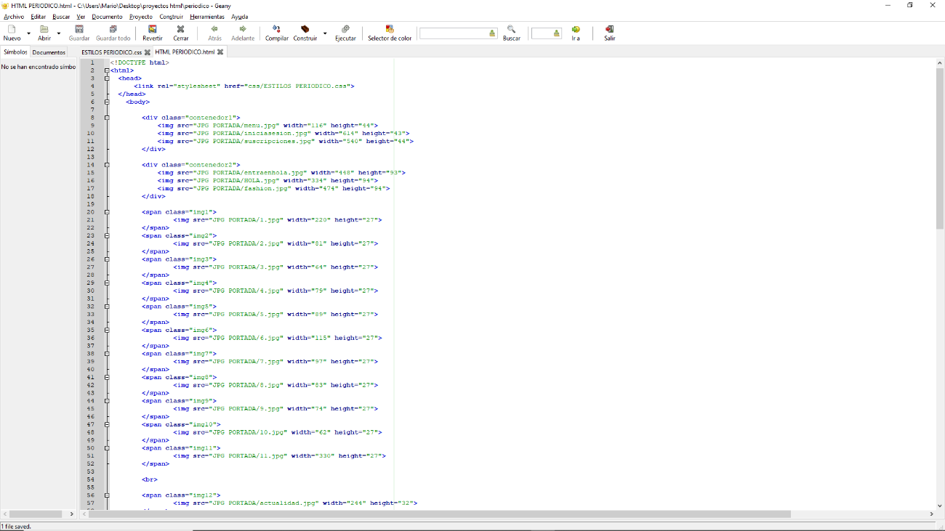

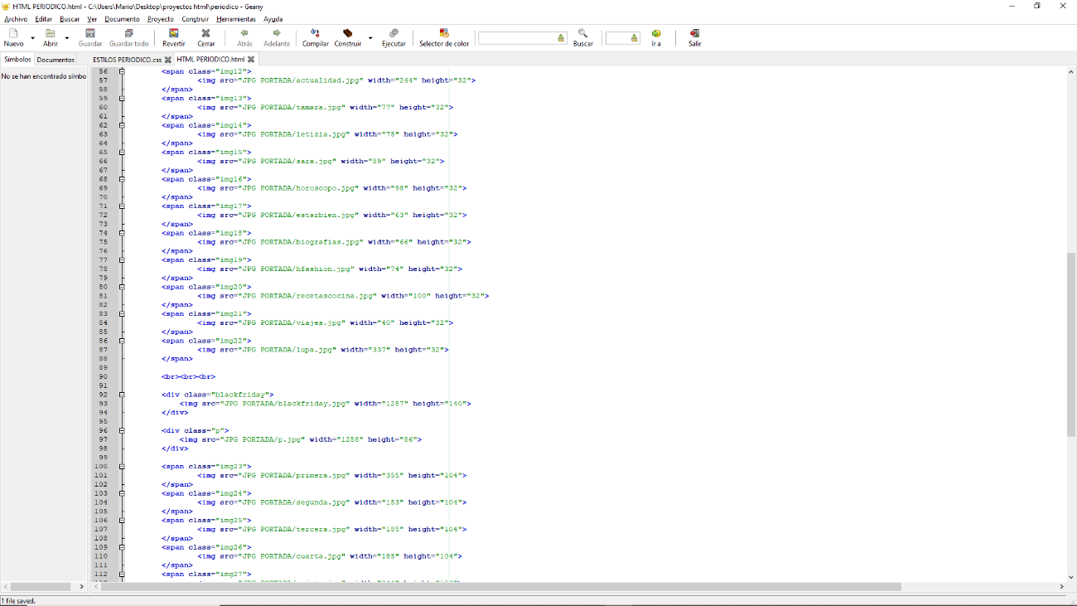

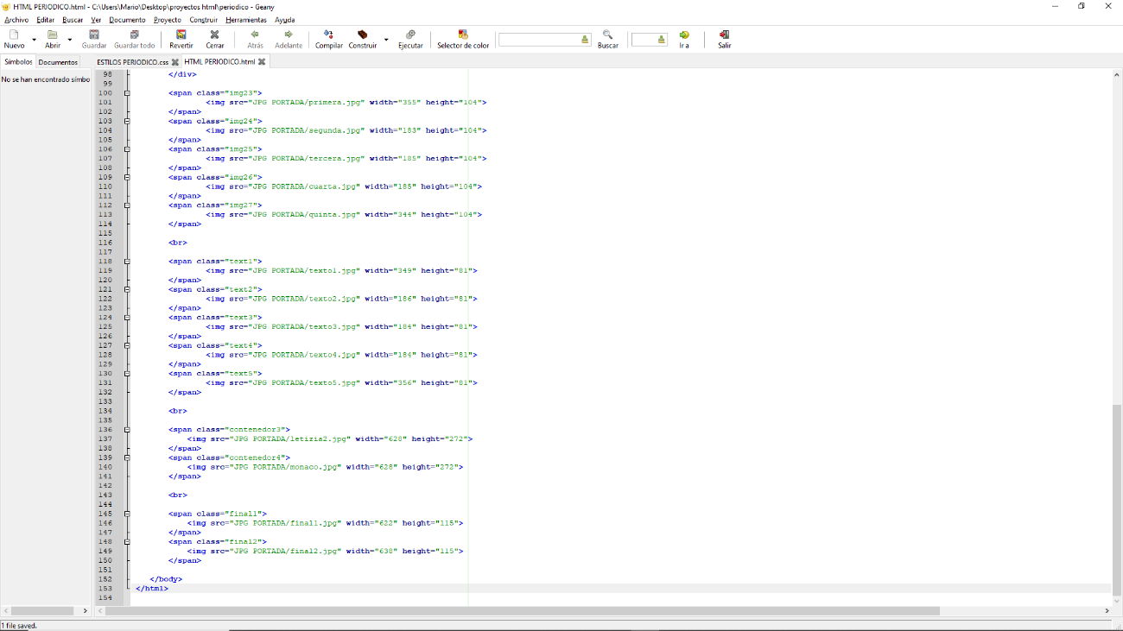

Código del html (utilizando los separadores nav y div )

<!DOCTYPE html>

<html>

<head>

<link rel="stylesheet" href="css/ESTILOS PERIODICO.css">

</head>

<body>

<div class="contenedor1">

<img src="JPG PORTADA/menu.jpg" width="116" height="44">

<img src="JPG PORTADA/iniciasesion.jpg" width="614" height="43">

<img src="JPG PORTADA/suscripciones.jpg" width="540" height="44">

</div>

<div class="contenedor2">

<img src="JPG PORTADA/entraenhola.jpg" width="448" height="93">

<img src="JPG PORTADA/HOLA.jpg" width="334" height="94">

<img src="JPG PORTADA/fashion.jpg" width="474" height="94">

</div>

<span class="img1">

<img src="JPG PORTADA/1.jpg" width="220" height="27">

</span>

<span class="img2">

<img src="JPG PORTADA/2.jpg" width="81" height="27">

</span>

<span class="img3">

<img src="JPG PORTADA/3.jpg" width="64" height="27">

</span>

<span class="img4">

<img src="JPG PORTADA/4.jpg" width="79" height="27">

</span>

<span class="img5">

<img src="JPG PORTADA/5.jpg" width="89" height="27">

</span>

<span class="img6">

<img src="JPG PORTADA/6.jpg" width="115" height="27">

</span>

<span class="img7">

<img src="JPG PORTADA/7.jpg" width="97" height="27">

</span>

<span class="img8">

<img src="JPG PORTADA/8.jpg" width="83" height="27">

</span>

<span class="img9">

<img src="JPG PORTADA/9.jpg" width="74" height="27">

</span>

<span class="img10">

<img src="JPG PORTADA/10.jpg" width="62" height="27">

</span>

<span class="img11">

<img src="JPG PORTADA/11.jpg" width="330" height="27">

</span>

<br>

<span class="img12">

<img src="JPG PORTADA/actualidad.jpg" width="244" height="32">

</span>

<span class="img13">

<img src="JPG PORTADA/tamara.jpg" width="77" height="32">

</span>

<span class="img14">

<img src="JPG PORTADA/letizia.jpg" width="75" height="32">

</span>

<span class="img15">

<img src="JPG PORTADA/sara.jpg" width="89" height="32">

</span>

<span class="img16">

<img src="JPG PORTADA/horoscopo.jpg" width="98" height="32">

</span>

<span class="img17">

<img src="JPG PORTADA/estarbien.jpg" width="63" height="32">

</span>

<span class="img18">

<img src="JPG PORTADA/biografias.jpg" width="66" height="32">

</span>

<span class="img19">

<img src="JPG PORTADA/hfashion.jpg" width="74" height="32">

</span>

<span class="img20">

<img src="JPG PORTADA/recetascocina.jpg" width="100" height="32">

</span>

<span class="img21">

<img src="JPG PORTADA/viajes.jpg" width="40" height="32">

</span>

<span class="img22">

<img src="JPG PORTADA/lupa.jpg" width="337" height="32">

</span>

<br><br><br>

<div class="blackfriday">

<img src="JPG PORTADA/blackfriday.jpg" width="1257" height="140">

</div>

<div class="p">

<img src="JPG PORTADA/p.jpg" width="1258" height="86">

</div>

<span class="img23">

<img src="JPG PORTADA/primera.jpg" width="355" height="104">

</span>

<span class="img24">

<img src="JPG PORTADA/segunda.jpg" width="183" height="104">

</span>

<span class="img25">

<img src="JPG PORTADA/tercera.jpg" width="185" height="104">

</span>

<span class="img26">

<img src="JPG PORTADA/cuarta.jpg" width="185" height="104">

</span>

<span class="img27">

<img src="JPG PORTADA/quinta.jpg" width="344" height="104">

</span>

<br>

<span class="text1">

<img src="JPG PORTADA/texto1.jpg" width="349" height="81">

</span>

<span class="text2">

<img src="JPG PORTADA/texto2.jpg" width="186" height="81">

</span>

<span class="text3">

<img src="JPG PORTADA/texto3.jpg" width="184" height="81">

</span>

<span class="text4">

<img src="JPG PORTADA/texto4.jpg" width="184" height="81">

</span>

<span class="text5">

<img src="JPG PORTADA/texto5.jpg" width="356" height="81">

</span>

<br>

<span class="contenedor3">

<img src="JPG PORTADA/letizia2.jpg" width="628" height="272">

</span>

<span class="contenedor4">

<img src="JPG PORTADA/monaco.jpg" width="628" height="272">

</span>

<br>

<span class="final1">

<img src="JPG PORTADA/final1.jpg" width="622" height="115">

</span>

<span class="final2">

<img src="JPG PORTADA/final2.jpg" width="638" height="115">

</span>

</body>

</html>

Finalmente, se consigue el resultado final, siendo igual al enunciado pedido.

